## **Overview**

Security Profiles is a collection of at least one role that grants access to specific endpoints and/or data in the OrderCloud.io API. Profiles can be assigned at any level in your organization's hierarchy. If a user attempts a request beyond the scope of their security profile assignments, they will receive 403 Forbidden response. Configuration of these profiles is possible within the [Security Profiles tab](http://localhost:3000/docs/guides/getting-started/dashboard-and-api-console#SecurityProfiles) in the OrderCloud.io Dashboard.

## **Roles**

Security Profiles are made up of roles, most of which can fall into one of two categories: Admin and Reader. An **Admin** role allows read and write access while a **Reader** role allows only read access. That being said, it would generally be considered redundant for a security profile to contain both an Admin and a Reader role for the same resource (since admins can always read).

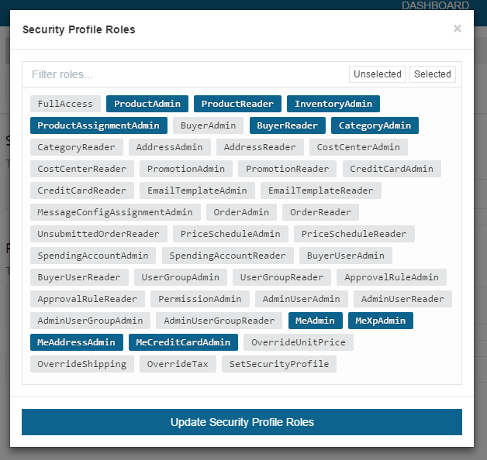

## **Assigning Profiles**

Security Profiles are assigned at the party level (User, User Group, Buyer Organization or Admin Organization).

POST https://api.ordercloud.io/v1/securityprofiles/assignments HTTP/1.1  
Authentication: Bearer put_access_token_here  
Content-Type: application/json; charset=UTF-8  
  
{  
 "SecurityProfileID": "ID_OF_YOUR_USER_SECURITY_PROFILE",  
 "BuyerID": null,  
 "UserGroupID": null,  
 "UserID": null  
}

Security Profile assignments, like most other assignments, cascade down from higher levels to the individual user, meaning the roles granted to the user are a cumulative collection of roles from every assigned security profile.